SML Homework

Jen McCall, John Mulcahy

### CS 361

1. What are the types of the following expressions?

* [(1,5), (2,3), (5,6)];
  + (int * int) list
* fun f(x:real) = true;
  + real -> bool
* map f;
  + ‘a list -> ‘b list

1. Provide expressions of the following types:

* int * bool

o (4, true)

* int list * bool

o ([5,8], true)

* int * real -> bool list

o (1,3.4)-> [true, true]

1. Write the following SML functions:



f(n) = 2^n

int -> int

fun exp(n) = if n=0 then

1

else exp(n-1) * 2;

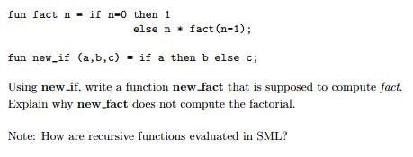

fun new_fact(a,b,c) = if a then b else c * fact(a, b, c-1);

new_fact(1,1,5)

This new_fact doesn’t run because our base case for factorial requires us to check if the number is equal to zero. In our ideal function, we are checking the value of a and then doing b, but this doesn’t work if a itself relies on the value of c. We can’t pass/check the value of c through a, so our base case in new_fact would never properly work. Furthermore, this would also rely on b always being equal to 1. If that’s the case, we should consider getting rid of the variable b and just requiring 1, it makes no sense to have the base case in the function parameters like that.

Define a function circumference that computes the circumference of a circle with respect to its radius. Use pi from the Math library.

fun circumference(r:real) =   
 2.0*Math.pi*r;  
   
circumference(14.0)

How to use map to add 3 to each elements of a list

val L = [1, 1, 2, 3];

fun addThree(x) = x + 3;

map addThree L;



fun addOne(L) =   
 if L = [] then []  
 else   
 tl(L) @ [hd(L)];

1. Implement the datatype BinaryTree and all the functions that are provided in the lecture notes: lookup, inorder, preorder, postorde, left_subtree, right_subtree and label. Provide screenshots to show that your code is correct. Provide 2 tests for each function.

